Week 7
1. Prunability / Pruning
1.1 Error injection (noise from 1 to 2, step 0.2)
This week, I performed extra error injection before going through the prunability.

Noise Std Ratio | Mean mAP50-95 Drop | Worst Layer | Worst Layer Type | mAP50-95 Drop
1.0 | 0.055542 | 0 | Conv | 0.377214
1.2 | 0.079599 | 0 | Conv | 0.440916
1.4 | 0.104702 | 0 | Conv | 0.480042
1.6 | 0.129678 | 0 | Conv | 0.495402
1.8 | 0.155179 | 0 | Conv | 0.503290
2.0 | 0.180400 | 0 | Conv | 0.506120
Table 1.1: Worst Layer in Different Noise Std Ratio

Table 1.1 shows the worst-performing layer at each noise standard deviation ratio. Layer 0 Conv is consistently the worst layer under all tested noise levels, indicating that the first layer is highly sensitive.

Noise Std Ratio | Top 1 | Top 2 | Top 3 | Top 4 | Top 5
1.0 | L0 Conv (0.377214) | L1 Conv (0.204935) | L3 Conv (0.172134) | L22 C3k2 (0.063782) | L19 C3k2 (0.061054)
1.2 | L0 Conv (0.440916) | L1 Conv (0.306741) | L3 Conv (0.258031) | L19 C3k2 (0.093783) | L22 C3k2 (0.089366)
1.4 | L0 Conv (0.480042) | L1 Conv (0.377071) | L3 Conv (0.338374) | L5 Conv (0.144487) | L19 C3k2 (0.133164)
1.6 | L0 Conv (0.495402) | L1 Conv (0.431620) | L3 Conv (0.390668) | L5 Conv (0.220997) | L19 C3k2 (0.168283)
1.8 | L0 Conv (0.503290) | L1 Conv (0.468379) | L3 Conv (0.430225) | L5 Conv (0.307871) | L2 C3k2 (0.215422)
2.0 | L0 Conv (0.506120) | L1 Conv (0.488925) | L3 Conv (0.457059) | L5 Conv (0.383447) | L2 C3k2 (0.273870)
Table 1.2: Top 5 Sensitive Layers at Each Noise Level

Table 1.2 lists the top five most sensitive layers at each noise level. Layers 0, 1, and 3 are consistently ranked in the top three.

Rank | Stable Sensitive Layer | Avg mAP50-95 Drop 1.0-2.0
1 | L0 Conv | 0.467164
2 | L1 Conv | 0.379612
3 | L3 Conv | 0.341082
4 | L5 Conv | 0.196045
5 / 6 | L19 C3k2 | 0.147826
5 / 6 | L2 C3k2 | 0.138414
Table 1.3: Top Six Sensitive Layers

Table 1.3 summarizes the most sensitive layers are L0 Conv, L1 Conv, and L3 Conv. These layers should be avoided for aggressive pruning, quantization, or hardware approximation because small changes may cause large accuracy degradation.

Noise Std Ratio | Mean mAP50-95 Drop | Best Layer | Best Layer Type | mAP50-95 Drop
1.0 | 0.055542 | 21 | Concat | 0.000193
1.2 | 0.079599 | 21 | Concat | 0.001843
1.4 | 0.104702 | 20 | Conv | 0.002861
1.6 | 0.129678 | 20 | Conv | 0.005061
1.8 | 0.155179 | 20 | Conv | 0.006593
2.0 | 0.180400 | 20 | Conv | 0.009400
Table 1.4: Best Layer in Different Noise Std Ratio

Table 1.4 shows the least sensitive layer at each noise standard deviation ratio. Layers 20 and 21 have the smallest mAP50-95 drops under most noise settings. This indicates that these layers may be safer candidates for model optimization.

Noise Std Ratio | Top 1 | Top 2 | Top 3 | Top 4 | Top 5
1.0 | L21 Concat (0.000193) | L20 Conv (0.002077) | L17 Conv (0.006762) | L7 Conv (0.008646) | L18 Concat (0.011195)
1.2 | L21 Concat (0.001843) | L20 Conv (0.003134) | L17 Conv (0.011663) | L11 Upsample (0.016501) | L18 Concat (0.017677)
1.4 | L20 Conv (0.002861) | L21 Concat (0.005016) | L17 Conv (0.017990) | L14 Upsample (0.023285) | L11 Upsample (0.023371)
1.6 | L20 Conv (0.005061) | L21 Concat (0.010577) | L17 Conv (0.021846) | L11 Upsample (0.029581) | L14 Upsample (0.033566)
1.8 | L20 Conv (0.006593) | L21 Concat (0.017259) | L17 Conv (0.028021) | L11 Upsample (0.039291) | L14 Upsample (0.042823)
2.0 | L20 Conv (0.009400) | L21 Concat (0.024550) | L17 Conv (0.035301) | L11 Upsample (0.052003) | L14 Upsample (0.056619)
Table 1.5: Top 5 Least Sensitive Layers at Each Noise Level

Table 1.5 lists the top five least sensitive layers at each noise level. Layers 20, 21, and 17 appear repeatedly among the least sensitive layers, meaning their accuracy impact remains small even when the noise level increases.
Upsample and Concat layers also appear in the least sensitive group, but since they contain no trainable parameters, they should be interpreted as graph-operation bottlenecks rather than weight-pruning targets.

Rank | Stable Least Sensitive Layer | Avg mAP50-95 Drop 1.0-2.0
1 | L20 Conv | 0.004854
2 | L21 Concat | 0.009906
3 | L17 Conv | 0.020264
4 | L11 Upsample | 0.028861
5 | L14 Upsample | 0.031456
6 | L18 Concat | 0.032434
Table 1.6: Top Six Least Sensitive Layers

Table 1.6 summarizes the top six stable least sensitive layers. L20 Conv has the smallest average mAP50-95 drop, followed by L21 Concat and L17 Conv.
These layers are the most suitable candidates for further pruning or optimization, especially L20 and L17 because they are Conv layers with trainable parameters.
For a layer:
y = Conv_or_Concat_or_Upsample(x)
The output:
y' = y + N(0, layer_output_std * noise_ratio)
e.g.
y = [100, 110, 120, 130]
std = around 13
noise_ratio = 1
y' = y + N(0, 13) = could be [113, 105, 107, 135]

1.2 Software Prunibility 1
For each layer i:
AccuracyDrop(i) = Avg(mAP50-95Drops(i)(noise=[1, 2], step=0.2))

$$\text{SWPrunability}\text{(i)}=\frac{\text{LayerLatency\%}\text{(i)}}{AccuracyDrop(i)}$$

Layer ID (sensitive) | Type | Params | Latency (%) | Avg mAP50-95 Drop 1–2 | SW Score
20 | Conv | 147712 | 0.892747 | 0.004854 | 183.907231
10 | C2PSA | 249728 | 7.831060 | 0.064518 | 121.377910
6 | C3k2 | 87040 | 6.486353 | 0.053956 | 120.214859
13 | C3k2 | 119808 | 6.695738 | 0.073697 | 90.854960
22 | C3k2 | 463104 | 9.122982 | 0.112209 | 81.303478
23 | Detect | 245466 | 31.132783 | 0.506632~ | 61.450487
16 | C3k2 | 34304 | 5.850978 | 0.100157 | 58.417966
8 | C3k2 | 346112 | 6.394054 | 0.128995 | 49.568167
4 | C3k2 | 26080 | 3.088444 | 0.067078 | 46.042921
17 | Conv | 36992 | 0.876574 | 0.020264 | 43.258054
19 | C3k2 | 95232 | 6.351932 | 0.147826 | 42.969074
2 | C3k2 | 6640 | 3.839889 | 0.138414 | 27.742023
21 | Concat | 0 | 0.269456 | 0.009906 | 27.200377
9 | SPPF | 164608 | 2.182773 | 0.119105 | 18.326537
7 | Conv | 295424 | 0.977588 | 0.057414 | 17.027096
11 | Upsample | 0 | 0.419100 | 0.028861 | 14.521243
14 | Upsample | 0 | 0.389719 | 0.031456 | 12.389469
18 | Concat | 0 | 0.287807 | 0.032434 | 8.873666
5 | Conv | 147712 | 1.274911 | 0.196045 | 6.503144
15 | Concat | 0 | 0.411435 | 0.065628 | 6.269231
12 | Concat | 0 | 0.325008 | 0.062207 | 5.224663
0 | Conv | 464 | 2.122852 | 0.467164 | 4.544126
3 | Conv | 36992 | 1.412386 | 0.341082 | 4.140901
1 | Conv | 4672 | 1.363431 | 0.379612 | 3.591645
Table 1.7: SW Prunability Table, Sorted by SW Score,

Table 1.7 presents the SW Prunability score, computed as Layer Latency (%) divided by the average mAP50-95 drop from noise 1 to 2. A higher SW Score means the layer has relatively high latency but low accuracy sensitivity, making it a better software optimization target.

Based on this table, L20 Conv, L10 C2PSA, L6 C3k2, L13 C3k2, and L22 C3k2 are the strongest candidates for software pruning or optimization.

1.4 Pruning
1.4.1 version 1
Step 1:
Structured amount sweeps on 17 prunable layers.
Amounts: 0.05, 0.10, 0.20, 0.30, 0.40, 0.50.
Step 2:
Unstructured sweeps on the same 17 layers.
Step 3:
Select best % for each layer using mAP50-95 drop <= 0.02.
Step 4:
For combination search, start with top 6 SW Prunability layers:
20, 10, 6, 13, 22, 16.
Step 5:
Run combination search at 0.1 first.
If accuracy drop is still small, repeat at 0.2.

Layers | Size | Amount | mAP50-95 | Drop | Zero % | Latency ms | FPS
20 | 1 | 0.1 | 0.489231 | 0.017401 | 0.630169 | 1.364058 | 733.107
13 | 1 | 0.1 | 0.470154 | 0.036479 | 0.492852 | 1.386044 | 721.478
10 | 1 | 0.1 | 0.466356 | 0.040276 | 1.055120 | 1.341391 | 745.495
20 | 1 | 0.2 | 0.459252 | 0.047380 | 1.260212 | 1.273073 | 785.501
20,13 | 2 | 0.1 | 0.452123 | 0.054510 | 1.122895 | 1.299932 | 769.271
20,10 | 2 | 0.1 | 0.437222 | 0.069410 | 1.685163 | 1.334319 | 749.446
10,13 | 2 | 0.1 | 0.417326 | 0.089306 | 1.547846 | 1.327530 | 753.278
Table 1.8: Structured pruning: mAP50-95 drop <= 0.1

Table 1.8 shows that structured pruning is sensitive to accuracy, but some, like layer 20, 13, are acceptable.

Layers | Size | Amount | mAP50-95 | Drop | Zero % | Latency ms | FPS
20,10,6,13,22,16 | 6 | 0.2 | 0.499182 | 0.007450 | 9.195488 | 1.257998 | 794.914
20,10,6,13,22 | 5 | 0.2 | 0.500218 | 0.006415 | 8.911136 | 1.325507 | 754.428
20,10,13,22,16 | 5 | 0.2 | 0.504057 | 0.002575 | 8.471755 | 1.332557 | 750.437
20,10,6,22,16 | 5 | 0.2 | 0.503538 | 0.003095 | 8.196069 | 1.259374 | 794.045
20,10,13,22 | 4 | 0.2 | 0.504265 | 0.002368 | 8.187402 | 1.357865 | 736.450
10,6,13,22,16 | 5 | 0.2 | 0.499296 | 0.007336 | 7.954796 | 1.341711 | 745.317
20,10,6,22 | 4 | 0.2 | 0.504110 | 0.002522 | 7.911717 | 1.305626 | 765.916
10,6,13,22 | 4 | 0.2 | 0.500617 | 0.006015 | 7.670444 | 1.344486 | 743.778
20,10,22,16 | 4 | 0.2 | 0.505637 | 0.000995 | 7.472336 | 1.343311 | 744.429
10,13,22,16 | 4 | 0.2 | 0.503863 | 0.002769 | 7.231063 | 1.327418 | 753.342
Table 1.9: Unstructured pruning top results by zero parameter percentage

Table 1.9 shows that unstructured pruning is less sensitive; the pruning amount can still be increased for further testing. I will perform that for the new equation.

For Tables 1.8 and 1.9, I will update them after using a new equation on SW Prunability. Or compare the results with the new combination of targeted layers.

2. PYNQ HW/SW co-design planning
The HW/SW co-design planning focuses on selecting candidate YOLO26n layers for future FPGA acceleration instead of accelerating the full model immediately.

A layer is a good FPGA acceleration candidate if it has:
- high latency percentage
- low mAP50-95 sensitivity
- repeated/simple computation structure
- pruning or quantization tolerance
- reasonable hardware implementation complexity

Component | Proposed location | Reason
Image loading | Software / ARM | File I/O is easier to manage in software.
Resize / normalization | Software first | Simple and easier to debug before hardware acceleration.
Early Conv layers | Possible HW candidate | Convolution is compute-heavy and repeated.
Middle Conv / C3k2 blocks | Strong HW candidate | Repeated structure, high computation, suitable for parameterized hardware design.
SPPF / feature aggregation | Software first or later HW candidate | More complex data movement.
Upsample / concat | Software first | Often memory-layout heavy rather than pure computation.
Detection head | Software first | Accuracy-critical and model-specific.
NMS / post-processing | Software / ARM | Easier to modify, debug, and visualize.
Visualization output | Software / ARM | Drawing boxes and labels is not suitable as first hardware target.
Table 2.1: Brief Thought about SW/HW Partitioning

The proposed (just my thought, I may not understand fully yet) partition keeps image loading, preprocessing, detection head, post-processing, and visualization in software because these parts are easier to debug and are closely related to input/output handling.

The main hardware candidates are convolutional and repeated feature extraction layers, especially layers with high latency percentage and low mAP50-95 sensitivity. This decision connects the previous profiling, error injection, pruning, and quantization analysis to the next stage of PYNQ-based hardware acceleration.

2.1 PYNQ Software role
In the PYNQ-based HW/SW co-design flow, the software side is responsible for controlling the full inference pipeline and connecting the Python-level application to the hardware accelerator.

According to the PYNQ development methodology, hardware overlays can be loaded into the programmable logic and controlled through Python APIs. [1]

Therefore, the software work does not only mean running the YOLO model in Python; it also includes preparing input images, sending data to the FPGA overlay, triggering hardware execution, collecting output data, and performing post-processing.

For this project, the software-side tasks can be separated into five parts:
1. Model preparation:
Export the trained YOLO26n model to ONNX and inspect the model structure.
2. Input preparation:
Load image/video/camera frames, resize them to the YOLO input size, normalize pixel values, and convert them to the data format required by the hardware design.
3. Python-to-HDL connection:
Use PYNQ Python APIs to load the FPGA overlay, allocate input/output buffers, send data to the accelerator, and control the hardware execution. [3]
4. Output processing:
Receive the output features or detection results from hardware and apply software-side decoding, confidence filtering, NMS if needed, and visualization.
5. Evaluation:
Measure latency, FPS, memory usage, and accuracy difference between software-only inference and HW/SW co-designed inference.

At this stage, the main software goal is to understand how Python can control hardware overlays and how YOLO data can be passed between the ARM processor and the programmable logic.

At the next step, we shrink the YOLO model to a size that can run independently on the Zynq Processing System (PS). The final step is HW/SW co-design of the full model on the PS and Programmable Logic (PL) of the Zynq SoC. Fig. 2.1 shows an overview of the final HW/SW co-design.
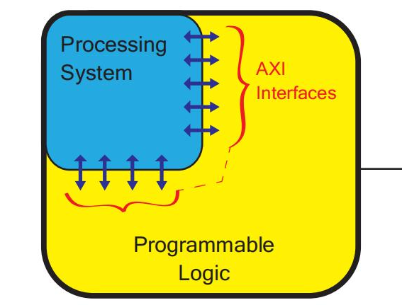
Figure. 2.1. Overview of the final HW/SW co-design

Processing System (PS): The blue area in the diagram. It is responsible for executing traditional software programs and operating systems.
Programmable Logic (PL): The yellow area in the diagram. This is essentially a flexible FPGA area. Designers can freely configure this area into custom hardware accelerators.
AXI Interfaces: Marked in red brackets in the diagram. This is the channel connecting the PS and PL. The processor (PS) can exchange data and coordinate control with the hardware logic (PL).

3. NN visualization using Netron
Netron is a neural network visualization tool that supports model formats such as ONNX, PyTorch, TensorFlow Lite, and others. [4]

After inputting an onnx file:

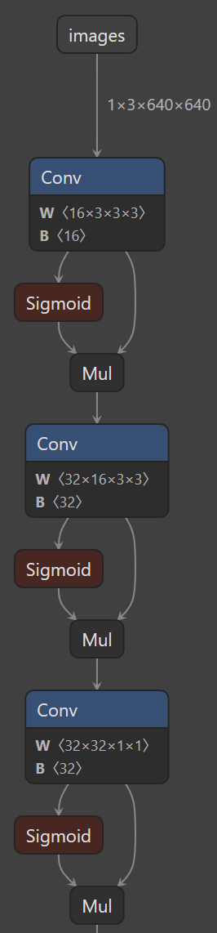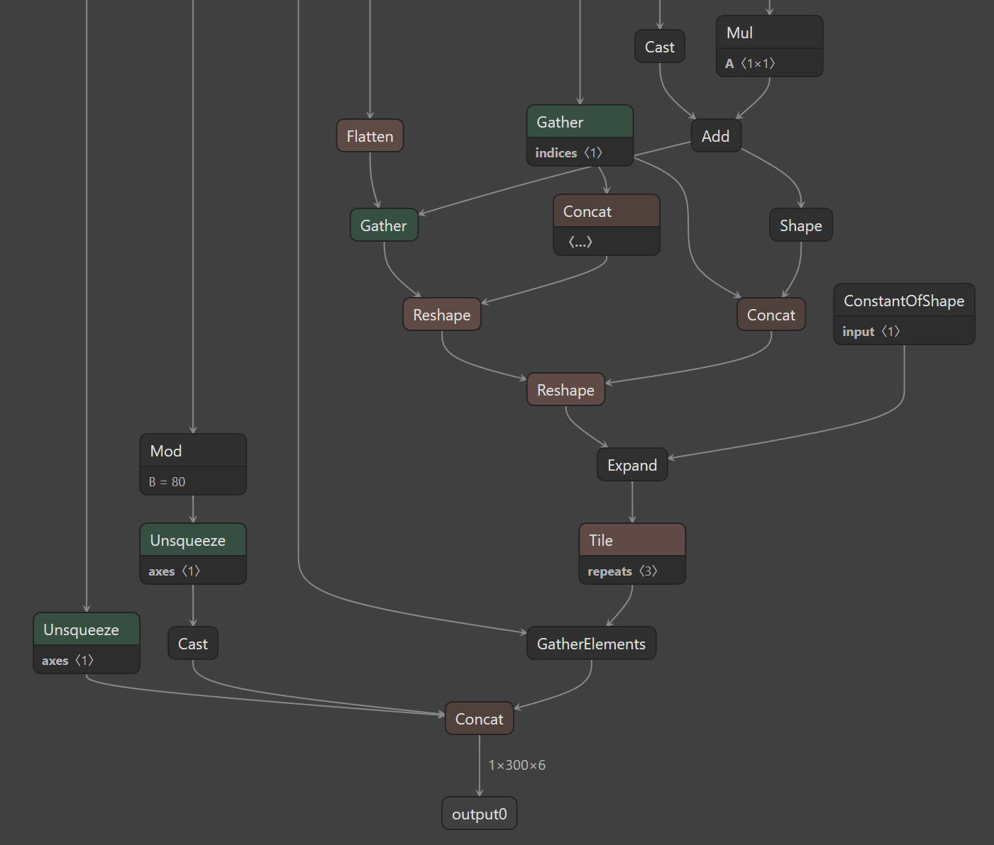
Figure 3.1: Netron GUI

Figure 3.1 shows the structure near the input image and the final outcome (the whole graph is huge). We can see the layers, such as convolution and concat, in the graph.

By visualizing the exported ONNX model, I can identify the order of YOLO26n layers, repeated blocks, input/output tensor shapes, and the connection between backbone, neck, and detection head.

In future development, Netron can be used for the following purposes:
1. Layer identification:
Match the layer IDs used in profiling and error injection results with the actual model graph.
2. HW/SW partition support:
Identify repeated Conv or C3k2-style blocks that may be suitable for FPGA acceleration.
3. Tensor shape checking:
Check the input and output tensor shapes of candidate layers before designing hardware interfaces.
4. Debugging model export:
Confirm whether the exported ONNX model keeps the expected YOLO26n structure.
5. Hardware side:
Provide a visual model graph: which operations should be accelerated.

Therefore, Netron is a visualization tool, and a reference for layer selection, software-to-hardware interface planning, and future debugging.

4. Embedded ARM inference plan
Plan and prepare ARM-only YOLO26n inference first.
FPGA acceleration can be added later after the HW/SW partition is confirmed.

Export to onnx:
yolo export model=model.pt format=onnx imgsz=640

Step | Action | Output
1 | Final model confirm | .pt
2 | Export YOLO26n to ONNX | .onnx
3 | Transfer ONNX model and test images to embedded board | Model + input image
4 | Run one-image inference | Detection output
5 | Measure latency | ms/image
6 | Compare with PC later | PC vs ARM table
7 | Select HW candidates | Based on profiling + sensitivity
Table 4.1: Workflow

Table 4.1 is the expected workflow.

Platform | Model | Runtime | Input size | Latency/image | FPS
PC CPU | YOLO26n | PyTorch / Ultralytics | 640 | pending | pending
PYNQ ARM | YOLO26n ONNX | ONNX / Python runtime  (if available) | 640 | pending | pending
PYNQ FPGA | Selected layers | Overlay | 640 | future | future
Table 4.2: Measurement table template

Table 4.2 is the expected measurement.

5. Recent competitors for snow traffic YOLO

Paper | Weather | Targets | YOLO version | Why useful for gap
YOLOv11-TWCS [10] | Rain, fog, snow, low-light / weather-degraded scenes | Autonomous-driving objects | YOLOv11-based | Recent YOLOv11 adverse-weather method; close competitor for robust traffic perception.
AWD-YOLO [11] | Adverse weather | Autonomous-driving object detection | YOLOv8n-based | Recent adverse-weather YOLO model based on YOLOv8n; useful for comparing against YOLO26n.
YOLOv11 and YOLOv8 for Mixed Traffic Object Detection under Adverse Weather [12] | Dense mixed traffic, rain, low-light | Mixed traffic objects | YOLOv11n and YOLOv8n | Recent benchmark-style competitor focused on accuracy, speed, and efficiency under adverse traffic scenes.
Table 5.1: Three recent papers on Snow / Adverse-weather Traffic YOLO

Although Table 5.1’s papers are not snow-specific, they are recent YOLO studies related to traffic adverse-weather. They are used to support the broader gap that YOLO26n has not yet been clearly studied for snow-affected traffic detection.

Next week, I will focus more on these papers’ methodologies, such as how they derived their proposed models from the baselines, what were their rationale and motivation for a new model rather than their baseline, etc.

5.1 Research gap
(I am trying to find a stronger gap other than this general gap. Some possible contributions are also stated in last week’s report, here is the general one)
There are two key points (combining papers from last week’s Table 9.1, and this week’s Table 5.1):
- not only [general + snow] specified
- no YOLO26n, not even YOLO26

Recent YOLO-based studies have investigated traffic object detection or traffic sign detection under adverse weather conditions, including snow, rain, fog, low-light, and mixed traffic scenarios.

These studies are mainly based on YOLOv8, YOLOv11, or other YOLO-based variants, and no clear published study was found that directly applies YOLO26n to snow-specific traffic object detection.

Therefore, a potential research gap is to evaluate YOLO26n for snow-affected traffic scenes while also considering model optimization and embedded deployment constraints.

7. Summary
1 Prunability equation update:
Additional error injection experiments with noise standard deviation ratios from 1.0 to 2.0 showed that early layers, especially L0 Conv, L1 Conv, and L3 Conv, are highly sensitive, while L20 Conv and L17 Conv are more suitable software optimization.

2 PYNQ HW/SW co-design planning:
The proposed HW/SW partition keeps input/output handling, preprocessing, post-processing, and the detection head in software first, while repeated Conv and C3k2 feature extraction layers are considered stronger future FPGA acceleration candidates.

2.1 PYNQ software role:
The software-side role in PYNQ is to control the full inference pipeline, including model preparation, input formatting, Python-to-HDL communication, output processing, and performance evaluation.

3. NN visualization using Netron:
Netron was used to inspect the exported ONNX model structure and will later support layer identification, tensor-shape checking, an d HW/SW partitioning.

4. Embedded ARM inference plan:
The next embedded deployment step is to run YOLO26n on ARM-only inference first, measure latency and FPS, and then compare it with the PC software baseline before FPGA acceleration.

5. Recent competitors for snow traffic YOLO:
Three recent adverse-weather YOLO-related papers were reviewed, and the current gap remains that no clear reviewed study was found applying YOLO26n specifically to snow-affected traffic object detection with embedded deployment considerations.

References

[1] PYNQ Documentation, PYNQ Introduction, 2025. https://pynq.readthedocs.io/en/latest/

[2] PYNQ Documentation, Overlay Design Methodology, 2025. https://pynq.readthedocs.io/en/latest/overlay_design_methodology.html

[3] PYNQ Documentation, Python Overlay API, 2025. https://pynq.readthedocs.io/en/latest/overlay_design_methodology/python_overlay_api.html

[4] Roeder, Netron: Visualizer for Neural Network, Deep Learning and Machine Learning Models, n.d. https://netron.app/

[5] Ultralytics, Ultralytics YOLO26, 2025. https://docs.ultralytics.com/models/yolo26/

[6] Jocher et al., Ultralytics YOLO26: Unified Real-Time End-to-End Vision Models, 2026. https://arxiv.org/abs/2606.03748

[7] Ultralytics, YOLO Performance Metrics, 2023. https://docs.ultralytics.com/guides/yolo-performance-metrics

[8] Ding et al., CF-YOLO: Cross Fusion YOLO for Object Detection in Adverse Weather with a High-Quality Real Snow Dataset, 2023. https://doi.org/10.1109/TITS.2023.3285035

[9] Chen and Fan, MSGC-YOLO: An Improved Lightweight Traffic Sign Detection Model under Snow Conditions, 2024. https://www.mdpi.com/2227-7390/12/10/1539

[10] Michael and Wang, YOLOv11-TWCS: Enhancing Object Detection for Autonomous Vehicles in Adverse Weather Conditions Using YOLOv11 with TransWeather Attention, 2026. https://www.mdpi.com/2624-8921/8/1/16

[11] Yuan et al., AWD-YOLO Enhancing Autonomous Driving Perception Reliability in Adverse Weather, 2026. https://www.nature.com/articles/s41598-025-29575-1

[12] Nguyen et al., Performance Analysis of YOLOv11 and YOLOv8 for Mixed Traffic Object Detection under Adverse Weather Conditions in Developing Countries, 2026. https://arxiv.org/abs/2606.12066

[13] Jiang et al., YOLO-DH: Robust Object Detection for Autonomous Vehicles in Adverse Weather, 2025. https://www.mdpi.com/2079-9292/14/22/4476

